**STA 471 – Regression Analysis**

**Homework #1**

**September 14th, 2023**

Richard McCormick

RLM443



1. Suppose that you are asked to fit a model to the data (Xi, Yi), i = 1, 2, ..., n. If the model is Y = β1X + ε, derive the least squares estimate of β1.

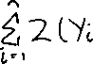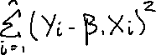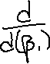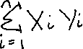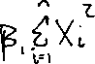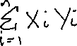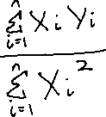

1. Show that the point (lies on the fitted line β0 + β1X.

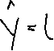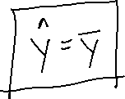

1. For the data given in problem F on page 99, consider the model Y = β0 + β1X + ε and answer the following questions (without the use of a statistical computer package):
2. Determine the equation of the fitted line.



|  |  |  |  |  |  |  |  |  |  |  |  |  |
| --- | --- | --- | --- | --- | --- | --- | --- | --- | --- | --- | --- | --- |
| X | 4.7 | 5.0 | 5.2 | 5.2 | 5.9 | 4.7 | 5.9 | 5.2 | 5.3 | 5.9 | 5.6 | 5.0 |
| Y | 3 | 3 | 4 | 5 | 10 | 2 | 9 | 3 | 7 | 6 | 6 | 4 |

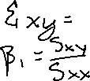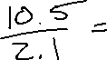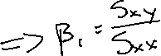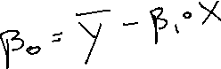

b) Construct a scatter plot of Y versus X and draw the fitted line on the plot.



c) Find out how much of the variation in Y is explained by the fitted line.

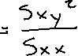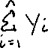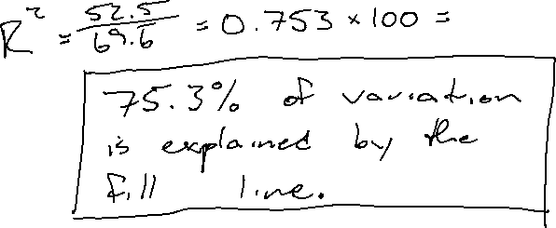

1. For the simple linear regression mode Y = β0 + β1X + ε, show:
2. SSreg = S2XY / SXX

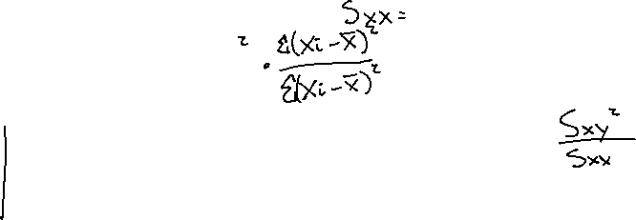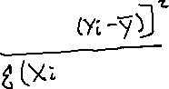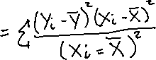

1. R2 = r2XY

